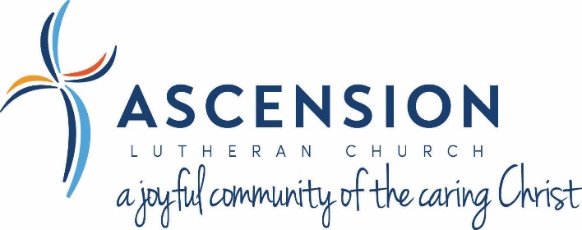
Annual Congregation Meeting – Sunday, December 4, 2022 – 10:00am

Opening Prayer: -Brian Black, Congregation President
Confirmation of Council: -Diane Topoleski, Congregation Vice President
- Notification of Candidates by council appointment or voting
- Nominations for LCMS Pres. And V.P.
- Question & Answer
- Motion of acceptance of council candidates by congregation
- Voting of acceptance by congregation (show of hands)
Greetings from the President: -Brian Black, Congregation President
Annual Financial Report: -Brian Black, Congregation President
- 2022 Budget review
- 2023 Proposed Budget
- Question & Answer- 10 minutes
- Motion
- Voting of acceptance by congregation (show of hands)

2022 Highlights and 2023 Vision: -Pastor Mark, Senior Pastor
Closing Prayer: -Pastor Mark, Senior Pastor

